Make What is the username to your database?

sictc

What is the password to your database?

Pencil1

What does SQL stand for again?

Sequence Query Language

What does the acronym CRUD stand for?

Create, Read, Update, Delete

What is the command to modify a selected table or db?

UPDATE

What does the 2 represent in the command ‘INSET INTO Contacts VALUES(2,’Payne’,’Max’);?

The ‘Id’

Are the keywords like INSERT, CREATE, VALUES, case sensitive? Can I make them lowercase?

YES YOU CAN

Submit a screenshot of your DB after you complete the challenge section on page db2.

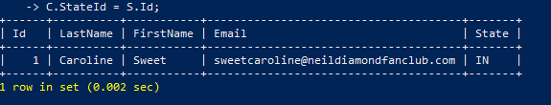

Submit a screenshot of the results of the Challenge on page db3.

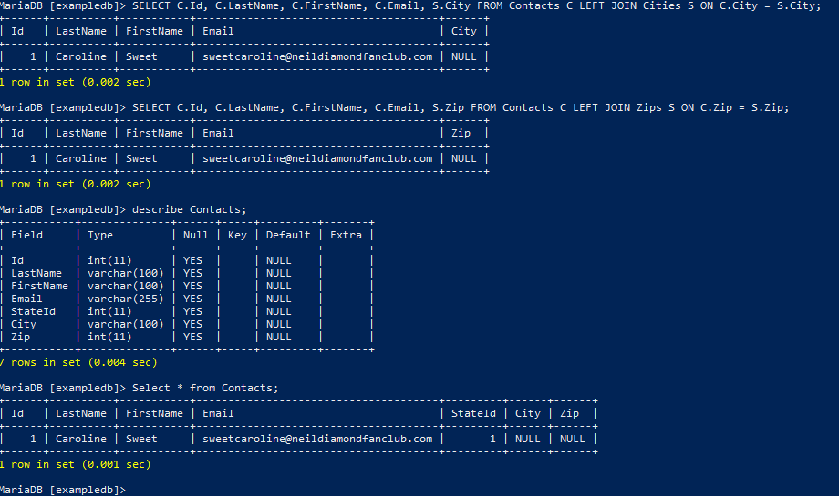

How many hours did you need to offset your time on the extra page to get to the correct time zone?

Fill in the blank below:

|  |  |
| --- | --- |
| Command | Definition |
| Ssh pi@ipaddress | Connect a secure shell to the raspberry pi |
| cat | Command to display contents of a file |
| sudo mysql –u sictc -p | Log into your database |
| SHOW DATABASES | MySQL lists all dbs |
| CREATE TABLE | MySQL command to create a new table |
| DELETE FROM table WHERE columnname IS NULL; | Remove a record |
| JOIN value | Merge the parameter of two table with the same title of the parameter |

New Database challenge:

You can use the same log in information for this activity. Take the Vrad activity we did before the snow break, and apply it to a list of vins provided by Mr. Bander. Convert each of the vin to vrad value and output the values into a csv file like below. Once you have the information converted, push all of the information to the database. You can either write out each command and hope you get it correct or use your tools. In the tutorial, we’ve talked about SCP and you have some JS and Python under your belt. May want to do some research… It is up to you.

Table headers: Vin wmiVrad desVrad serVrad

wmi is the 1st 3 characters

des is the next 8 chacters

ser is the remaining characters

